**BI And Data Warehouse**

**What is need for BI?(Business Intelligence)**

Business Intelligence is the activity which contributes to the growth of any Company.

**Planning-> Data Gathering -> data Analysis -> Business Action**

Business Intelligence is act of transforming raw/operational data into information for business analysis

Bi extracts data from company operational transaction ,and transform the data by transforming the data we mean cleaning and integration of the data and loaded to data warehouse

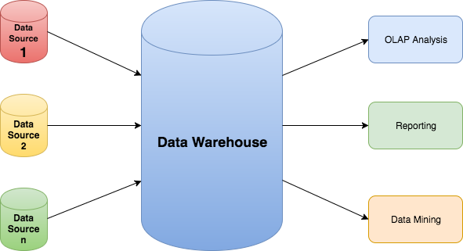

**Data Warehouse**

Data Warehouse is the Centralized repository where all the data from one or more heterogeneous data source .

The data in DW system is used for analytical Reporting ,which is later used by business analyst ,sales manager etc for decision making

The data in Data warehouse is Denormalized and cannot update,delete only loaded

Data Warehouse is used for reporting and analyzing of information and stores both historical and current data

Data multidimensional form me hota the stor->cube

The data is transformed->cleaned->integrated->loaded in warehouse